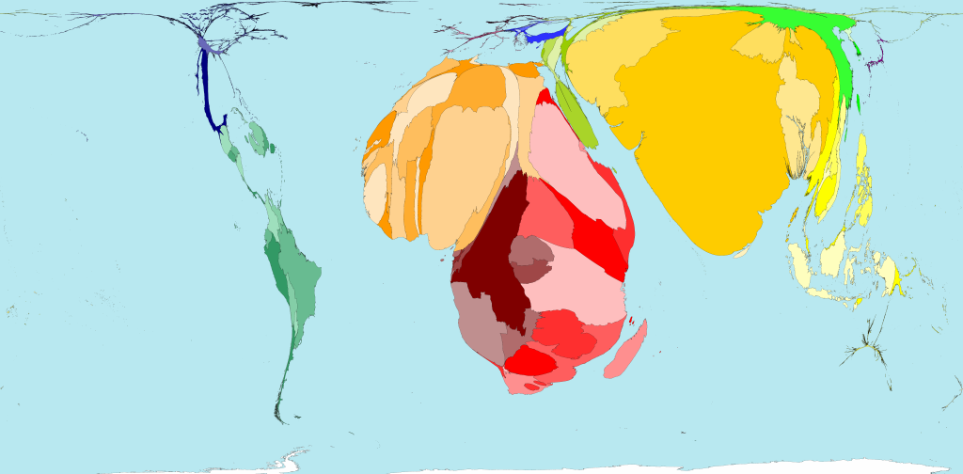
Worldmapper.org
WHO Estimates: Maternal Mortality - http://www.who.int/mediacentre/factsheets/fs348/en/

This map magnifies the disease burden (maternal mortality) and shows that 99% of these deaths take place in lower-income countries.
Every day, approximately 800 women die from preventable causes related to pregnancy and childbirth.

Praktische Verloskunde
Our World in Data, 2017 - https://ourworldindata.org/maternal-mortality

The maternal mortality ratio = the number of women who die from pregnancy-related causes while pregnant or within 42 days of pregnancy termination per 100,000 live births.
In many countries it is still unacceptably high.
The MMR for The Netherlands is 5 deaths per 100,000 live births.
The MMR for Kenya is 342 deaths per 100,000 live births, giving the term “motherhood” a very different connotation.
While motherhood is often a positive and fulfilling experience, for too many women it is associated with suffering, ill-health and even death.
The risks of becoming a mother in Kenya are something women have to take into consideration when praying to fulfill their wish for children.

Praktische Verloskunde

Five preventable complications account for more than 70% of maternal deaths:
Haemorrhage (25%)
Infection (15%)
Unsafe abortion (13%)
(Pre)eclampsia (12%)
Obstructed labour (8%)

The remainder are caused by or associated with diseases such as malaria and AIDS during pregnancy.
Most of these deaths are avoidable as the health-care solutions to prevent or manage these complications are well known.
So WHY are women STILL dying during pregnancy and childbirth in an age of global health advocacy and healthcare as a universal human right?

In 2000, the United Nations established 8 MDGs with the aim to address the needs of the world’s poorest by the target date of 2015.
MDG 5 was aimed to:
-reduce the maternal mortality ratio by 75 percent,
-and achieve universal access to reproductive health.
At the time of my research in 2012, Kenya was “off track” in achieving these goals – making me want to understand why.

In the meantime, new SDGs have been created of which SDG Target 3 aims to:
-reduce the global maternal mortality ratio to less than 70 per 100,000 live births by 2030,
-and ensure universal access to sexual and reproductive health-care services by 2030.
Unfortunately, Kenya is still “off track.”
https://ourworldindata.org/maternal-mortality

